Team Application Exercises (tAPP-3)
Instructions: Work on problem 1 on your own to apply the concepts you learned in the pre-reading material to solve problems. Then discuss your code with your team members and present one solution as a team. Follow the same process for all the problems. Swap your team solution with another team for feedback.
Problem 1
Write code that creates a database called employees. That database contains a table called contactDetails. The following output will be produced when the program is executed.
(72, "Derrick", "Brown", "0122345 8765"),
(42, "Simon", "Pierre", "0142678 9056"),
(62, "Katarina", "Iglesias", "0203456 7078")

Problem 2 - Debugging code
A user has written a Python script that is supposed to create a new CSV file, ask the user to input the name and age of a person, and then add this information to the end of the file. The script is also supposed to allow multiple records to be added in one session. However, when running the code, it does not execute due to some errors.
Task 1: Identify the errors (making sure you indicate the line number) and how many errors have you found?
Code with errors
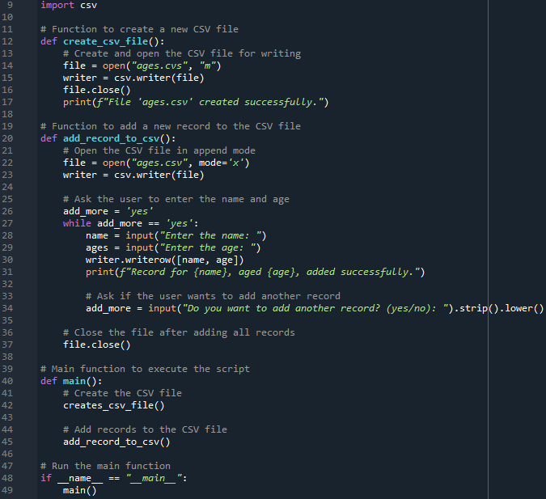

Problem 3 - Parsons puzzle
Rearrange the following code snippets to correctly insert data into an SQLite database. Rearrange the code by entering the number that corresponds to each statement/block of statements (the first number has been entered for you).
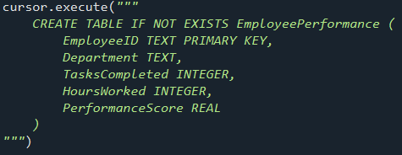
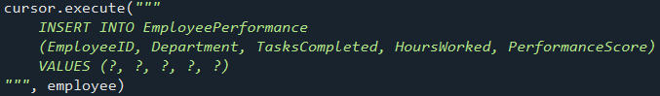

1

Problem 4
This program below should allow the user to convert between miles and kilometres. 1 kilometre = 0.6214 miles and 1 mile = 1.6093 kilometres.
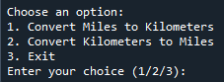
Task: Using a pen and paper, complete the code (with correct indentation).
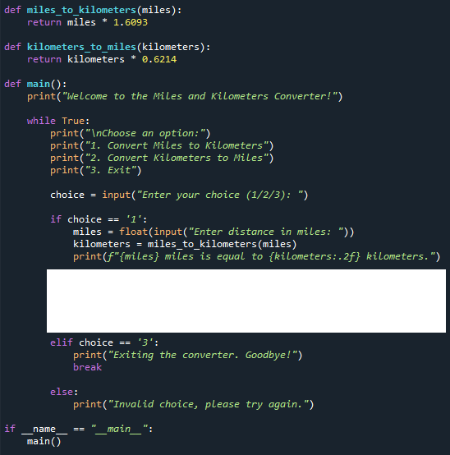

Problem 5-1

The following program should ask the user for the name of a text file and display its contents. If the file does not exist, it should display:
File not found. Please try again.
and ask for another filename.
The program contains three errors.
Task: Identify the three errors and write the corrected version of the program.
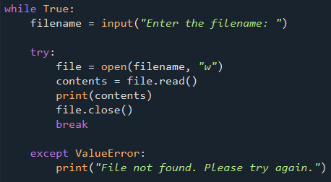

Problem extra
The following code is intended to load a CSV file and filter data by the most recent year. However, it throws an error when trying to access the ‘Date’ column. Debug the code to fix the issue.
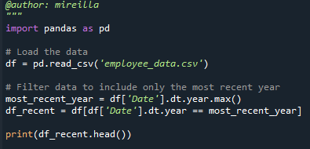

Problem 6 - Debugging
Which of the following codes intended to create a PyTorch tensor and apply the ReLU activation function will throw an error? What is the error?
(1)
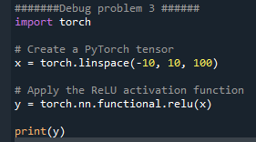
(2)
